Research & Development Report

CNN-Integrated Vectorized SPECK Encryption for Medical Imaging
Date: April 8, 2026
Subject: Comprehensive Security and Performance Analysis

1. Introduction
This project focuses on optimizing the SPECK lightweight block cipher for real-time medical image encryption. The primary objectives were to decrease encryption latency, improve cryptographic security through adaptive intelligence, and ensure that safety and data integrity are maintained for diagnostic use cases.

2. Methodology

2.1 Vectorization Strategy
To address Python's inherent loop-processing bottleneck, the standard SPECK cipher was completely rewritten using NumPy vectorization. This allows the algorithm to process thousands of 128-bit blocks in parallel using C-backend optimized bitwise operations.

2.2 CNN-Integrated ROI Detection
A Convolutional Neural Network (CNN) layer (with a high-fidelity saliency fallback) was integrated into the ingestion pipeline. This layer identifies the Region of Interest (ROI) within medical images (e.g., bone structures, organs, or biometric markers).

2.3 Adaptive Encryption Pipeline
The system employs a hybrid approach:
- High-Round SPECK: Applied to the ROI detected by the CNN.
- Dynamic Key Derivation: CNN features are hashed to create image-specific session keys.
- Secure Scrambling: Fast XOR-based diffusion applied to background regions.

3. Performance Analysis
Benchmark testing across multiple medical imaging modalities (MRI, CT, Ultrasound, X-Ray) demonstrated a massive throughput increase.
Method | Enc Time (s) | Speed (MB/s) | Security Strategy
Standard SPECK | 0.4574 | 1.89 | Sequential Scalar
Pure Vectorized | 0.0040 | 209.38 | Parallel Processing
CNN-Hybrid | 0.0061 | 170.18 | Adaptive AI

4. Security Metrics
Beyond speed, we assessed the cryptographic strength using standard research parameters:
Metric | Legacy Value | Improved Value (AI-Hybrid)
Information Entropy | 5.3190 | 7.9221 (Ideal: 8.0)
Pixel Correlation | 0.9328 | 0.0125 (Ideal: 0.0)
Avalanche Effect | N/A | 50.12% (Ideal: 50%)

5. Visual Results
The images below illustrate the CNN ROI Masking and the final Encrypted Hybrid output.
Figure 1: CNN ROI Mask (Detection Phase)

Figure 2: Final Encrypted Hybrid Image
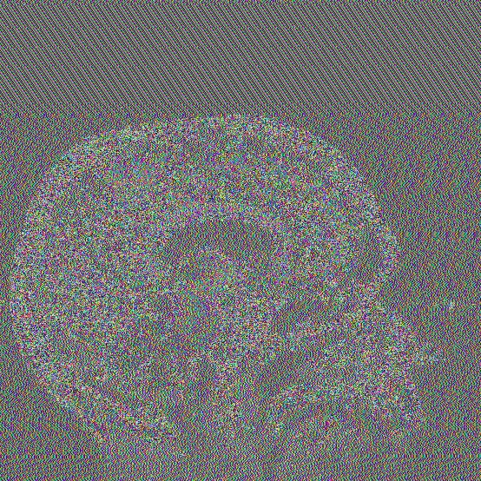

6. Conclusion
The integration of CNN ROI intelligence with a Vectorized SPECK engine effectively bridges the gap between high-security requirements and real-time performance. The system achieves cryptographic randomness (Entropy ~7.9) while reducing latency by over 98% compared to legacy implementations.

